Colo HIGH SCHOOL

learning and support team procedural document

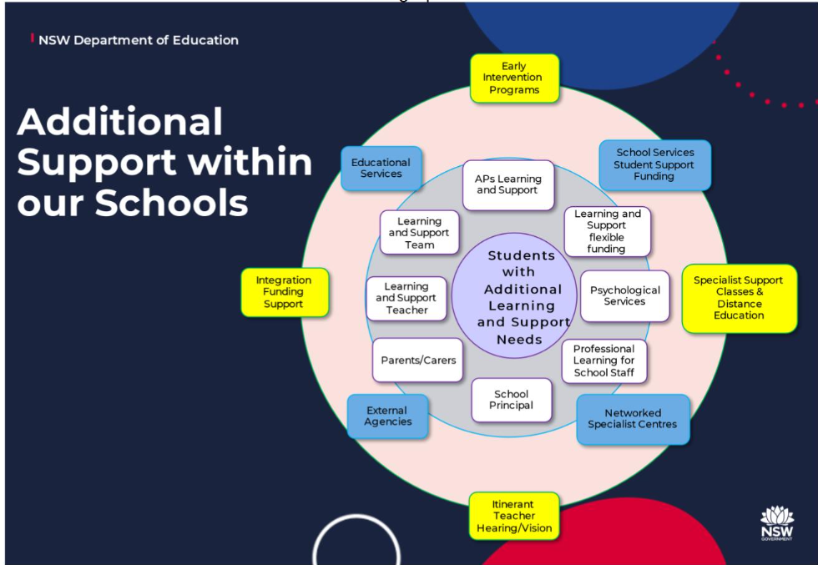

rationale

The Learning Support Team is an integral part of Student Wellbeing with the aim to ensure all students with Learning Difficulties (both formally diagnosed and teacher nominated) are offered appropriate support. The role of the Learning Support Team is to:

* continually upskill in information and resources
* set up and improve learning and support structures
* build teacher capacity and support teachers in catering for students with learning difficulties
* identify and implement reasonable school based provisions and adjustments
* develop and support effective school partnerships and learning pathways
* support ongoing collaborative planning between students, teachers, parents/ caregivers and other professionals
* monitor special provisions across all year groups
* meet student needs

The LST at Colo High School is composed of the following staff:

* Senior Executive
* Learning Support Coordinator
* School Counsellor
* Student Support Officer (SSO)
* Head Teacher Administration
* Learning and Support Teacher (LaST)
* Small Group Tuition Teacher
* Careers Advisor
* Student Learning Support Officers (SLSO)

meeting cycles and planning schedules

The Learning and Support Team meet Monday, Periods 6, Week A in 2023 and will move to Mondays 2.20pm in 2024.

**Learning and Wellbeing Meeting Cycle 2024**

**Rationale**

In order to be pro-active in supporting all the students of Colo High School a variety of different LST meetings need to be scheduled into the school calendar cycle, in advance, to allow all appropriate staff time to prepare and attend meetings.

**Learning and Wellbeing Meeting Cycle 2024**

|  |  |  |  |
| --- | --- | --- | --- |
| **Meeting** | **Attendees** | **Purpose of meeting** | **When** |
| LST Meeting | Appropriate DP  LSC/ LaST/ Additional staff as appropriate  Any teacher is welcome to attend. | To view new referrals, document support and implement support for individual students.  Feedback to staff from LAST/ Counsellor/ YA as appropriate. Also through LSC at Exec Meetings. | Wednesday Week A and B  Pd 5  Staff Common Room |
| LST Access Request Meetings | LSC/ LaST/ Counsellor/ DP / appropriate YA | To collate/ prepare information for Access Request. | As required. |
| LST support staff daily check-ins/meeting | LSC/ LaST/ SLSO | Communication and ongoing monitoring issues | Each morning before school at 7.55am in Wellbeing Hub |
| Learning Support Faculty Meeting | HT/ LaST/ SLSO/ Counsellor | Updates from Executive Meetings, Faculty Planning, General Business, discussion of ongoing issues, etc | As per in school calendar, in M5. |

All meetings are scheduled on SENTRAL to allow access to agendas and minutes for all staff.

**Learning and Support Scope and Sequence (Term Overview Planner)**

The following overview (Appendix 12.1) seeks to provide a guide to operations from withing the Learning and Support Team. It also depicts the District Panel Meetings dates and key whole school programs.

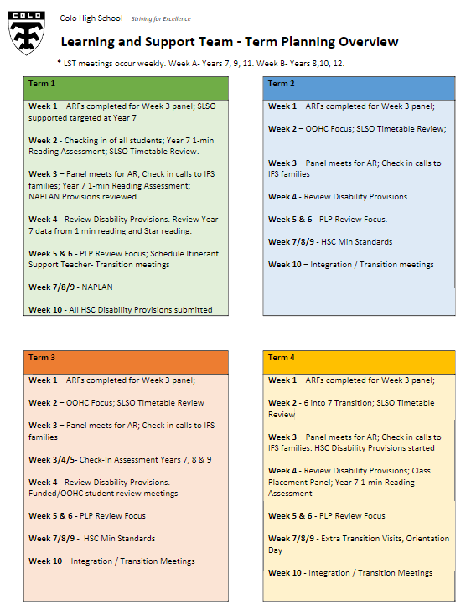

learning support roles and responsibilities

The Learning Support roles and responsibilities are listed as both the below visual overview (Appendix 12.2) and also in point form under role responsibility statements:

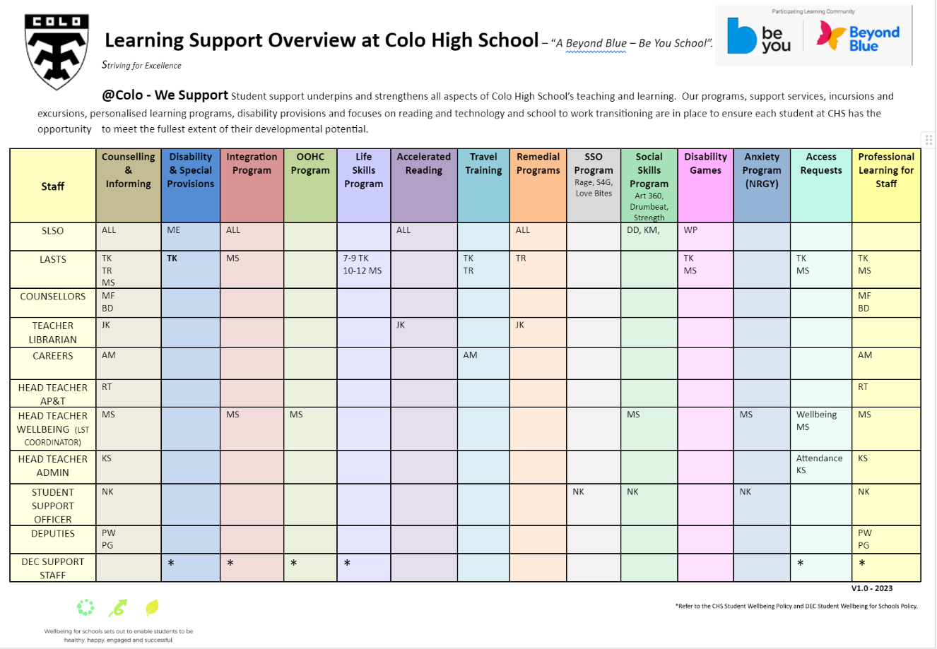

**Responsibilities of staff to Learning Support**

It is the responsibility of the **Principal:**

* to “ensure the implementation of support for students who experience difficulty” DOE Policy.

It is the responsibility of the **Deputy Principal**:

* to support and promote the work of the Learning Support Team
* to monitor the work of the Learning Support Team
* to respond appropriately to any on-going complaints relating to the work of the Learning Support Team
* to work with the Learning Support Teams in supporting all students, in respective year groups
* to attend Learning Support Team meetings and facilitate required actions
* to attend meetings where student needs are above that of support delivered by staff within a school setting

 It is the responsibility of the **Learning Support Team Coordinator:**

* to have line management oversight for the work of LaST, SSO, SLSO’s, School Chaplain and other support personnel
* to monitor the efficient running of the Learning Support Team
* to monitor and promote the timetables of SLSO’s and LaSTs
* to liaise with student, parents and teachers on issues to relating to Learning and Support
* to be lead and facilitate the Intergration Funding Support program, including planning and review of PLPs
* to respond appropriately to initial requests and complaints relating to the Learning Support Team
* to attend Learning Support Team meetings and help facilitate required actions
* to have oversight for and support staff in the writing of Access Requests, including Transition Plans
* to represent the Learning Support Team at the School Executive/ Senior Executive level (when requested)
* to manage the school counsellor referral system in collaboration with DPs and SCS
* to schedule and manage LST meetings including the writing of minutes
* to receive the Leaning Support Team referrals and to ensure that each referral is dealt with, within an appropriate timescale
* the writing of Transition Plans in collaboration with other staff
* to schedule and manage Learning Support Faculty Meetings as per staff meeting calendar

It is the responsibility of the **School Counsellor:**

* to support and promote the work of the Learning Support Team in dealings with students, teachers and parents
* to provide direct counselling service for students on their case loads and also drop-ins or self-referrals
* to liaise with student, parents, teachers and appropriate external agencies on counsellor caseload
* to communicate with and /or implement requests for Cognitive or Behaviour Assessment from external stakeholders and supports where LST supports the need
* to provide upskilling to staff who have agreed to complete a cognitive or behaviour assessment
* to implement advice from external counsellors, psychologists or psychiatrists through PLPs
* to work collaboratively with Learning Support Team, staff, parents/caregivers and other agencies to develop school-based support for students
* to carry out assessment of students referred by the Learning Support Team when appropriate permission has been given by parents
* to complete the counsellor Access Request section when applicable
* to attend and contribute to the Annual Review Process
* to update and initiate Disability Confirmation Sheets for students
* to support the delivery of outcomes of a referral including delivery of professional learning to teachers
* to refer students to the Learning Support Team when required
* to complete Safety Plans

It is the responsibility of the**Student Support Officer**:

* to have an understanding of school, department and national policies relating to students with disabilities
* to actively engage in the Learning Support Team Faculty to gauge student needs and support required
* to work with referrals from Deputy Principals and SASS to gauge student needs and support required
* to Collaborate with Deputy Principals to support students who require Behaviour Plans and positive interventions
* to Support attendance procedures and follow-up for individual students where possible
* to Coordinate targeted programs of support for students to meet their needs ie. social skills and positive relationship programs
* to Publish these programs of support on the Wellbeing Scope and Sequence after ongoing evaluation. Suggestion of programs include Love Bites, RAGE, RAP, Seasons for Growth, Mental health First Aid and RIOT.
* to coordinate and organise a timetable of work and distribute to teams
* to document on Sentral daily operations and incidences of support through Wellbeing - Learning Support - NCCD
* to allocate approx. 2-3 periods per day allowing for reactive needs of students and families throughout the day
* to document any students removed from class on Sentral on PXP for attendance needs
* to engage and be present in day-to-day school operations, such as school VTR’s and professional learning

It is the responsibility of the **Head Teacher Wellbeing:**

* to continue to support and promote the importance of Student Wellbeing across the whole school
* to have line management oversight for the work of the team of Year Advisors
* to manage the Wellbeing Faculty budget and resources to ensure efficient and effective use
* to actively promote Wellbeing throughout the school in terms of making resources available to both students and staff
* to monitor the efficient running of the Wellbeing Scope and Sequence
* to support and guide Year Advisors through implementation of specific Year Group programs as per Wellbeing Scope and Sequence
* to liaise with student, parents and teachers on issues to relating to Wellbeing to respond appropriately to initial requests and complaints relating to the Wellbeing Team
* to attend Wellbeing Team Meetings and help facilitate required actions
* to lead the Anti-Bullying planning and program annually
* to lead and implement Health Care and Transgender Plans
* to lead and facilitate the NSW Health Adolescent Vaccination Program each year
* to lead the PL in areas of Student Wellbeing
* to represent the Wellbeing Team at the School Executive/ Senior Executive level (when requested)
* to schedule and manage Wellbeing meetings including the writing of minutes
* to receive the Wellbeing referrals and to ensure that each referral is dealt with, within an appropriate timescale
* the writing of Wellbeing and Medical plans in collaboration with staff, students and parents

It is the responsibility of the **Head Teacher Administration:**

* to continue to support and promote the importance of Student Attendance and Learning Support across the whole school
* to attend LST meetings and contribute to LST processes
* to have systems and processes in place to effectively monitor the attendance of students at school
* to engage with the Home School Liaison Officer and key staff from District Office when students at risk are needing support to attend school
* to document and distribute to staff an attendance plan for students who are at risk communicating what is in place to support them in the classroom and beyond
* to complete Part Day Attendance Exemption Plans for students needing a partial attendance option to support their needs
* to complete Access Request applications for students who are on an attendance plan or HSLO caseload looking for Distance Education enrolment support

It is the responsibility of all **Faculty Head Teachers:**

* to be current and ongoing training in Learning Support and lead the implementation of adjustments and Learning Support across the subject areas they lead/ manage
* to ensure staff under their direct supervision read and implement Personalised Learning Plans
* to ensure staff under their direct supervision complete Progress Reports in a timely manner
* to ensure staff under their direct supervision are reporting appropriately to through the Academic Report process
* to ensure staff under their direct supervision are able to register adjustments and provide samples or evidence if requested by LaSTs
* to support and promote the work of the Learning Support Team in dealings with students, teachers and parents
* to devise appropriate systems within their faculty area to ensure students are monitored and recorded at the classroom teacher level, such as program registrations and uploaded evidence
* to ensure their staff are aware of students requiring Disability Provisions and they are implemented during assessments
* to liaise with faculty teachers and the Learning Support Team as required for individual cases

It is the responsibility of the **LaST**:

* to develop a program of work to include the implementation of HSC Minimum Standards, Disability Provisions, 6 into 7 Transition Support, Out of Home Care, Literacy and Numeracy Support, Life Skills Support
* to assess students levels of literacy and numeracy through various programs including SA Spelling, Reading Speed, YARC, Pat Assessments
* to collate appropriate information and data from teachers, SENTRAL, NAPLAN data and other sources including carrying out additional reading and numerical tests.
* to collate any relevant data for use in a learning support referral including collecting working with the YA for Progress Reports
* to extend feedback to teachers (and parents/ carers), as appropriate the decisions of the Learning Support Team
* to support and helping teachers with any relevant professional learning
* to design and write PLPs in conjunction with students, parents, carers, teachers, counsellors and any other appropriate stakeholder for students requiring adjustments to their learning.
* to liaise with parents, carers, teachers, counsellors and any other appropriate stakeholder regarding learning needs and PLPs
* to implement advice from external agencies including Occupational Therapists and Speech Pathologists through student PLPs
* ensure Disability Provisions for examinations and assessments are accessed and implemented for all year groups for all assessments, including NESA
* ensure OOHC policies are followed as in the policy for government schools
* responsible for monitoring and support of OOHC students
* to work collaboratively with other LaSTs to ensure even distribution of workload ie. 7-10 and 11-12

It is the responsibility of the **SMALL GROUP TUITION TEACHER**:

* to actively engage in the Learning Support Team Faculty to gauge student needs and support required.
* to primarily utilise school data to inform of caseloads
* to work with caseloads over two sessions per year
* to document pre and post testing as well as evidence of work to upload as part of the bi-annual census needs.
* to work with referrals from the Learning Support Team, Stage Coordinators and Year Advisors
* to work with other schools systems and processes to identify students in need of support to complete classwork ie. Accelerated Reading Programs and Post-Suspension referrals.
* to liaise between Deputy Principals to support students who are on Faculty Monitoring and in need of tuition and support.
* to coordinate, organise and document on Sentral a daily record of students who will be removed from class to work in small groups, or who will attend Small Group Tuition during their study periods or lunchtimes.
* to generate a list of students who need targeted support through analysing Accelerated Reading data.
* to communicate with parents/carers to inform them of student participation in Small Group Tuition.
* to develop and/or access support material where required to effectively help students achieve curriculum goals.
* to engage in regular day-to-day teaching operations, such as roll call, playground duties and professional learning.

It is the responsibility of the **Year Advisor:**

* to support and promote the work of the Learning Support Team in dealings with students, teachers and parents
* to manage school counsellor referrals for the designated year group through a LST referral on Sentral
* to liaise with parents, students and teachers for the year the Year Advisor has responsibility for
* to attend Learning Support Team meetings for their year group as needed
* to collate any relevant data for use in a learning support referral including collecting Progress Reports for information
* complete the Year Advisor comment for Access Requests section when applicable
* to inform and make regular recommendations to Deputy Principals and Head Teachers in terms of class placement and social dynamics where needed

It is the responsibility of all **Student Learning Support Officers**:

* to have an understanding of school, department and national policies relating to students with disabilities
* to attend classes of targeted students to support their outcome achievement
* to register their attendance and support through Sentral entries
* to provide roll call support for literacy / numeracy / dyslexia needs and to support targeted students needing organisation support
* to ensure they are working under the direct supervision of a teacher at all times
* to attend faculty, staff and LST Meetings as required. If not present, ensure meeting minutes are read
* to dispense medication when needed
* to provide VTR support, such as camps and curriculum excursions with approval
* to work with LST Coordinator and Counsellor in contributing to Access Request Applications and Integration Funding Support Reviews
* to attend students meetings when required by SET/LST and log these under Sentral
* to liaise with parents and carers, via the phone, under the request of the LST
* to work with the SLSO team each term to evaluate and review each SLSO timetable to ensure students are receiving adequate support and double-ups are minimised ie. Indigenous students and IFS students
* to ensure personal timetable is accurate and updated on the Google DataShare Learning Support Drive and you are attending these classes
* to build in a suitable break period if on duty during lunch and recess (lunchtime games, active working under supervision, mentoring, medication dispensing etc) and ensure this is reflected on both timetable and Sentral entries.
* to refer students to Wellbeing Staff when students need support
* to work in the Learning Centre under the direct supervision of the Teacher Librarian when students require one-on-one support
* to follow regular staff systems and processes, such as Code of Conduct and Dignity and Respect in the Workplace Charter
* To complete the annual PDP process for SASS staff

It is the responsibility of the **Careers Advisor**:

* to attend LST meetings regularly or when required and give advice to staff to support solving student needs
* to develop and communicate an array of support mechanisms available to students in need of transition to work support structures
* to coordinate, document and facilitate the Transition to Work plans on Sentral and communicate these to staff

It is the responsibility of **all staff**:

* to have an understanding of school, department and national policies relating to students with disabilities
* to consider and make suitable adjustments to support students with a Learning Disability (either diagnosed or imputed), in line with Disability Standards for Education (2005) aand national disability policies.
* to know their students and how they learn
* to read the PLPs attached to students in their classes through Sentral
* to implement all aspects of students PLP, such as Disability Provisions
* to be responsible for adjustments such as additional resources in assessments, tasks, classroom learning activities, resources required to implement their curriculum
* to liaise with Learning Support Team if they need discrete supervision etc during assessment periods
* to read and implement the Wellbeing and Learning Support Document distributed at the beginning of each year
* to develop and implement a seating plan based on both Wellbeing and Learning Support needs
* to implement suggested adjustments and strategies in student PLPs
* to liaise with the Students Learning Support Officers attached to students within their class and collaboratively discuss how they can best support the student each lesson
* to consider/ make appropriate referrals to the Learning Support Team when they have concerns about a student on going progress or academic development and their classroom adjustments are not enough
* to respond to requests for information/ data within a reasonable timescale (maximum of 3 working days) about any student referred to the Learning Support Team to allow the team to meet and make recommendations in a reasonable time scale
* to provide specific information to be used by Year Advisors in responding to parental progress enquiries and when necessary in the Access Request or Funding Review processes
* to attend Learning Support Team meetings to explain further their concerns (if required)

Personalised support for student learning role descriptions can be found here:

<https://education.nsw.gov.au/teaching-and-learning/disability-learning-and-support/personalised-support-for-learning/roles-and-responsibilities>

learning support operations

The following diagram depicts the steps involved in providing support to address student needs across the school:

|  |  |  |  |  |
| --- | --- | --- | --- | --- |
| **Step 1: Learning Support Team and Year Advisors collaboratively develop Wellbeing Notes, PLPs or Wellbeing Plans based on enrolment Information.** | | | | |
| **Social/ emotional** | **Cognitive** | **Sensory** | **Physical** | ‐ Records from Prev. Schools  ‐ Years 6‐7 transition  ‐ Testing Data  - Attendance  ‐ Counsellor records  ‐ Information from    alternative setting  Shape‐ From parents/ students |
| E.g. Behaviour, Mental health, Family, Relationship | E.g. Organisation, Literacy, Numeracy | E.g. Hearing, visual | E.g. Temporary, permanent |
| **Step 2: Teacher gathers information** | | | |
| ‐ Is there a flag and student plan on SENTRAL?  ‐ Is there already a Learning and Support program in place? (Consult Learning and Support Teacher).  Shape‐ Have you raised the student with other staff? E.g. Year Advisor, Counsellor,       Careers Advisor, Deputy Principal. | | | |
| **Step 3. Teacher implements class/ individual modification strategies** | | | |
| Shape‐ Consult NESA and Department of Education Adjustment Resources.  ‐ Teacher documents adjustments made/ collects evidence. | | | |
| **Step 4. Teacher discusses need for additional strategies with Head Teacher** | | | |
| ‐ Head Teacher recommends additional strategies.  Shape‐ Teacher implements additional strategies and collects evidence of adjustments  made. | | | |
| **Step 5. Teacher Submits Learning and Support Referral** | | | |
| ‐ Learning and Support Team meet to discuss and review student data/evidence.  ‐ Learning and Support Team to decide on interventions required.  Shape‐ Intervention could include referral to counsellor, suggestions of teaching strategies for individual teachers/all class teachers, referral to outside agencies, in‐class support for teachers through SLSO support, further assessment, consultation with parents, Personalised Learning Plan support.  ‐ Learning and Support Team communicate to staff. | | | | |
| **Step 6‐ Sustained intervention required, inclusion on NCCD** | | | | |
| ‐ Consultation with parents/carers/students to develop Personalised Learning Plan (PLP).  ‐ LaST determines adjustments required and determines the levels of adjustment.  - Consultation with LaST re recommended adjustments for assessment tasks.  Shape‐ LAST enters onto NCCD register.  ‐ Communication with staff and enters flag on students SENTRAL profile.  ‐ Documentation by all class teachers of adjustments made for student using PLP when required. | | | | |
| **Step 7‐ Monitor progress** | | | | |
| Shape‐ Year Advisors and LaSTs collect and collate data from PLASPs filled out by classroom teachers.  ‐ Formal Review Meetings and LST Meetings to determine further adjustments or removal of adjustments. | | | | |

support from within the classroom

Colo High School has an Adjusted Learning Policy (Appendix 12.3). It is heavily upon the Education and Communities Every Student, Every School Policy (Appendix 12.3).

Teachers are responsible for meeting the learning needs of the students in their classes. This may be a supported process utilising the expertise of more experienced mentors from within their faculties or their Head Teachers. Supports that teachers can implement are depicted below. These adjustments are to be registered on the teaching and learning program and also referenced in reports if needed.

Twice per year – staff will be asked to upload examples of adjustments to support the NCCD process. This is done through:  Sentral – Wellbeing – Learning Support – Evidence of Support for NCCD.

|  |  |  |
| --- | --- | --- |
| *Academic / Cognitive* | *Behavioural* | *Least to Most Intrusive Strategies* |
| * Tasks broken into smaller steps * Provide scaffolds and prompts * Provide a copy of whiteboard notes * Use visual supports! * Short concise instructions * Concrete materials (multi-sensory learning) * Present learning in a range of formats or mediums * Pre-teach, re-teach * Team teaching * SLSO support * Cooperative learning groups * Partner work * Introduce new concepts with known/familiar activities * Immediate feedback on learning * Learning intentions/success criteria * Task list * Written and verbal instructions * Learning walls * Modelling * Rephrasing * Verbal and written instructions * Mindmapping * Repetition * Adjusted workloads/assessments/tasks * Refer to data – Scout, Sentral, diagnostic, LST, pre-tests * Refer to student Individual Education Plan – utilise strategies | * Clear expectations and consequences * Expectations / rules clearly displayed and reinforced * Utilise the least to most intrusive strategies * Establish routines and procedures * Individual/ small group / whole class activities * Cater for learning styles of student * Universal trauma informed practices * Checklists for behaviour * Reward system * Refer to Student Behaviour Support Plan – utilise strategies * Refer to student Risk Management Plan – utilise strategies | * Tactical ignoring * Non-verbal messages * Casual statement or question * Simple directions * Rule restatement/reminder * Questions and feedback * Distraction or diversion * Defusion * Deflection * Simple Choice * Take the student aside * Clear command / assertive message * Broken record * Move students to a quiet space in the room * Time-out desk * Follow up / follow through * Exit from room / send to / for HT |
| *Physical* | *Social / Emotional* | *Health / Medical* |
| * Seating plan * Activities for students to move around the room * Classroom setup allows free movement around the room * Adjust lighting * Visual supports * Hearing/visual support informs student seating * Reset / Timeout area in faculties | * Build positive relationships with students * Positive feedback to students and home * Predictability – consistent classroom routines * Predictability - prepare students for any change to routine * Social Stories for specific activities * Take Space in class * Brain breaks | * Refer to students HCP and make appropriate adjustments * Seek advice as required |

**When to refer to the Learning Support Team?**

After teachers have adjusted work for students there may still be barriers to their learning. Teaching staff need to call and speak with parents to discuss the barriers to the student accessing work in their class and gain some insight and feedback from parents. This also needs to be discussed and negotiated with their Head Teacher.

When ongoing, informative assessment still demonstrates that students cannot access learning outcomes with the adjustments you have implemented, you will need to make a referral to the Learning Support Team for additional support.

learning support referrals

The Learning Support Referrals are accessed and documented through clicking:  Sentral – Wellbeing – Referral – Add referral

Referrals are for support in the classroom or to engage in a learning program. This is not for Wellbeing concerns. Wellbeing concerns can be discussed with the Year Advisor who will be able to process support, if required.

A referral can be added after a classroom teacher has implemented any existing PLP and made classroom adjustments to their teaching and learning program. This is documented when registering your program. It is also referenced when reported to parents and carers. I.e.. *“Jake has engaged well in Geography this semester and benefited from an adjusted program of study.”*

Each referral will be address at the upcoming Learning Support Team meeting.

**What can be expected from Follow-up from Referral**

LST Coordinator when chairing the meeting will:

1. Open the referral under ACTION REQUIRED and the team will discuss and the nature of the request as a new referral.
2. Team will develop strategies and supports that may be available, such as withdrawal groups, small group tuition, SLSO support or liaising with parents to investigate learning needs.
3. PLP may be developed and disseminated to staff.
4. Supports to be actioned will appear on the LST Meeting Minutes.
5. Supports to be actioned will be communicated back through the EXECUTIVE MEETINGS.
6. Any additional advice, support or PL will be actioned by the LaSTs
7. An outcome of the referral may be the LST prompting teachers to adjust the tasks given to the student as needed.
8. Edit the referral under ACTION REQUIRED and check the COMPLETED button at the base of the page.

learning support meetings

Weekly meetings are held by the Learning Support Team, with year groups alternating between odd and even weeks for focused attention. The DP overseeing 7, 9 and 11 will attend once per cycle and the other DP overseeing 8, 10 and 12 will attend the alternate week. The purpose of these meetings is to document new referrals of teaching and learning concerns and apply appropriate supports. These minutes are available to all staff to view.

The Learning Support Team Coordinator chairs the meetings and is responsible for minutes and dissemination through Executive Meetings. The agenda is as follows:

1. Follow-up Referrals from last meeting
2. New Referrals
3. Attendance
4. General Business

Staff are to complete a referral if they need support which is not in place. Teachers are reminded that the first layer of support comes from all classroom teachers making adjustments for their students of they feel it is required for them to access the curriculum.

**Contact with outside agencies / student supports**

The staff in charge of coordinating the support of students in terms of outside agencies is depicted below. The originals of all diagnosis (such as diabetes, depression or dyslexia) are to be kept in the students personal record in the front office. Copies may be kept in Counselling files, Learning and Support files or Sentral Files should staff feel the need to kept a copy more accessible.

personalised learing plans (plpS)

A Personalised Learning Plan aims to summarise a students needs and the learning adjustments required under the Disability Standards for Education Act 2005 (Appendix 12.5). It is written in consultation with student, parents, outside support agencies as best practice. Plans are downloaded and attached as a current version, before being modified.

PLP’s are written by and reviewed by the Learning and Support Teachers. The steps for PLP development are as follows:

Other plans follow a similar process, but are completed by key staff members as set out below:

Personalised Learning Plans are available on Sentral and it is the responsibility of teaching staff to engage with these documents and facilitate the required adjustments.

LEARNING SUPPORT MATRIX OF SUPPORT

Again, teaching staff are responsible for meeting the learning needs of the students in their classes. Supports that teachers can implement are depicted below. These adjustments are to be registered on the teaching and learning program and also referenced in reports if needed.

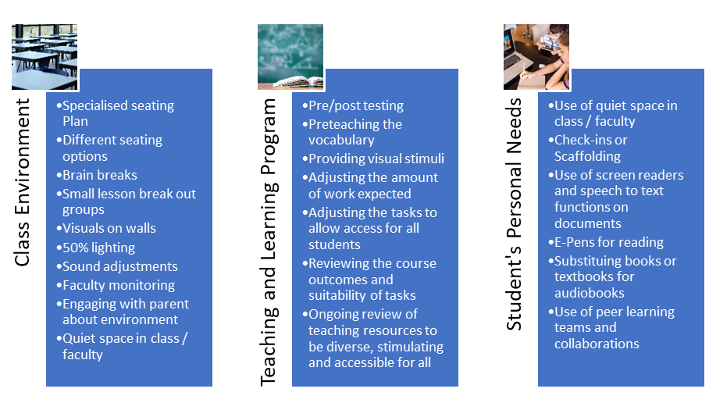

Additional possibilities where support can be offered or implemented through the Learning and Support Team include:

**SLSO classroom support**

Student learning support officers can be timetabled onto classes to assist the functioning of the classroom. Whilst they may be there for targeted support for one or more students, they are able to work with all students in the room. Their roles are varied and dynamic. Best practice for a positive collaboration between SLSOs and teachers involves a plenary conversation before students enter the room regarding who they are here to support and how the teacher can maximise their skillsets.

SLSO’s will register their support of students on Sentral and data will be used to inform review of fundings and future support needs.

**Withdrawal Programs**

LaSTs, COVID ILSP Teachers, SLSOs (working under the direction of teaching staff) and SSO run targeted withdrawal groups to provide specialised or remedial work for referred students. These groups include: Literacy, Numeracy, Accelerated Reading, Intensive Spelling, Rip It Up Reading and …

There are also additional Withdrawal programs aimed towards developing positive social interactions through practical,  project based work. These include DrumBeat, Strength Program and Art360.

**Roll Call Initiatives**

Programs held during roll call time can also be accessed by students as an additional support strategy. Peer Literacy, Peer Numeracy, Kirinari and Leap Roll Calls are in place to provide students with access to teachers, programs and additional learning opportunities to bridge gaps in learning or develop stronger skillsets or confidence levels.

**Playground Duty Support**

Students may require additional support at recess and lunch. This may be to keep them safe, active or busy during non-structured times. An extra teacher in a specific area may be

**Relief to Engage in Professional Learning**

Staff who are experiencing complexities within their teaching and learning roles may apply for funds to support their ongoing learning and supporting student needs. This may be in the way of an online course in Autism or Life Skills Programming.

**Other**

Funding is available to support targeted students and can be used for wages for SLSOs or staff only. Any initiatives or programs which may be of benefit to meet individual learning needs can always be assessed and reviewed by the Learning Support and Senior Exec Teams.

LIFE SKILLS PATTERN OF STUDY

The decision for the implementation of Life Skills would only occur after the progress of the student and supporting evidence has been considered and discussed at LST. The parent and student would then be invited to a transition meeting to ensure that all parties are clear about the long term ramifications of the decision.

Prior to the implementation of Life Skills:

* LST referral from one or several teachers that has been considered by Head Teacher/s.
* Investigation by LST including:
* School counsellor records
* Feeder school comments and reports if appropriate
* School progress reports
* NAPLAN results
* Results of in school testing
* LaST assessments
* Observations in class
* Documentation and evidence of adjustments and differentiation to curriculum / assignments
* PLP
* Disability provisions
* Discussion with student regarding adjustments that would be helpful
* LaST working with teacher regarding strategies and further adjustments
* Continue to monitor and support student
* Parents and student consulted about any support provision proposed
* Further discussion at LST

If the decision is to proceed with Life Skills, schedule Transition meeting with DOE Transition Teacher, parent, student and relevant school personnel to discuss the Life Skills option and the implications for the student’s long term goals. Decision needs to consider Life Skills in all or some subjects. Also whether or not they will complete exams during exam periods.

If all stakeholders are in agreement, parents sign permission for Life Skills (Appendix 12.4). This is forwarded to Head Teacher Admin to complete NESA enrolments.

Staff are informed and implementation of Life Skills course commences.

ASSESSMENT TOOLS which could be utilised to inform of need for Life Skills include:

**YARC York Assessment of Reading and Comprehension**

Reading rate – age given

Reading accuracy – age given

Comprehension – age given

Normed to 16 years

It comprises two sets of prose passages, both fiction and non-fiction for students age 11 to 16. These passages are designed to be read silently and are accompanied by 13 comprehension questions and a final summarisation question. (Supplementary and Additional Supplementary Passages) for students whose reading age is below ten years of age and are accessible at a reading age of 6.05.

**South Australia spelling test**

Normed to 6 years to 15 years

Standardised test

Graded words

Will show phonetic, syllabification, spelling of common letter strings and some irregular words

**PAT Maths: Progressive Achievement Test in Mathematics**

Suitable for years 2 to 10 – 7 booklets

Contains multiple choice questions in – number, space, measurement, chance and data, and patterns and algebra

disability provisions

The is an ongoing adjustment to students’ assessment needs, based on need and feedback from teachers, students, parents and learning and support staff and external supports.

Schools are responsible for determining and approving adjustments for all school-based assessment tasks, including those of junior school. These are based on NESA Disability Provisions to ensure integrity, validity and reliability. NESA determines disability provisions for the Higher School Certificate examinations.

A list of these provisions and associated rules can be located here. <https://www.nsw.gov.au/education-and-training/nesa/hsc/disability-provisions/support-types>.

Disability provisions in the HSC are practical arrangements designed to help students who couldn't otherwise make a fair attempt to show what they know in an exam room. The provisions granted are solely determined by how the student’s exam performance is affected. It is not embarrassing to apply for provisions, and more than 7000 HSC students apply for provisions each year. Provisions help students to show the markers what they know and can do.

To apply for provisions, schools must submit an online application to NESA. This application informs the provision/s a student is requesting and includes recent evidence. Evidence may include medical reports, reading results, spelling results, writing samples and teacher comments.

In  non-HSC school assessments at Colo High School – we practice a resilience based approach, where all structures are to be implemented by classroom teachers, with the support of SLSO’s / exam supervision etc when requested. However,  students have the flexibility to opt out if they feel they are ready to demonstrate resilience and growth and not require the disability provision. Medical disabilities such as diabetes and epilepsy are always strongly encouraged to utilise their provisions each time.

A list of students accessing Disability Provisions is available to support classroom teachers on the front of Sentral as indicated below. It is the responsibility of Teachers and Head Teachers to be aware that these students require ongoing adjustments to classwork, as well as assessment tasks, as indicated through their PLPs.

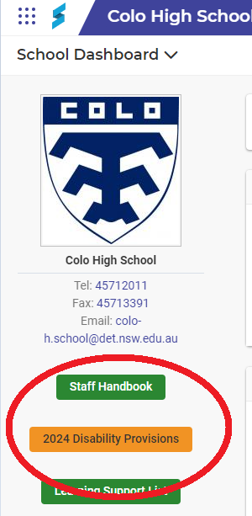

appendix

**12.1 Scope and Sequence – Term Planner Overview**

[Learning and Support Team Term Planner Overview.docx](https://schoolsnsw.sharepoint.com/:w:/r/sites/ColoHighSchoolExecutiveCommunication/Shared%20Documents/General/Learning%20Support%20Procedural%20Document%202024/Learning%20and%20Support%20Team%20Term%20Planner%20Overview.docx?d=wb181e1b93be04431bab65251549a1e49&csf=1&web=1&e=elY7HH)

**12.2 Learning Support Roles and Responsibilities Overview**

[2024 Overview & Learning Support Roles .docx](https://schoolsnsw.sharepoint.com/:w:/r/sites/ColoHighSchoolExecutiveCommunication/Shared%20Documents/General/Learning%20Support%20Procedural%20Document%202024/2024%20Overview%20%26%20Learning%20Support%20Roles%20.docx?d=w2599483cf5e94d068bef3c4d5de69c95&csf=1&web=1&e=TcXtFe)

[2024 Role of the Learning and Support Teacher.docx](https://schoolsnsw.sharepoint.com/:w:/r/sites/ColoHighSchoolExecutiveCommunication/Shared%20Documents/General/Learning%20Support%20Procedural%20Document%202024/2024%20%20Role%20of%20the%20Learning%20and%20Support%20Teacher.docx?d=wde76d45d3c444e83a8aa46b24cfd34b8&csf=1&web=1&e=6wZr8Y)

[2024 Role of the SLSO .docx](https://schoolsnsw.sharepoint.com/:w:/r/sites/ColoHighSchoolExecutiveCommunication/Shared%20Documents/General/Learning%20Support%20Procedural%20Document%202024/2024%20Role%20of%20the%20SLSO%20.docx?d=w361cc419b0214998955f38a7a54fbb5d&csf=1&web=1&e=ZQ4UYV)

[2024 Role of the Small Group Tuition Teacher .docx](https://schoolsnsw.sharepoint.com/:w:/r/sites/ColoHighSchoolExecutiveCommunication/Shared%20Documents/General/Learning%20Support%20Procedural%20Document%202024/2024%20Role%20of%20the%20Small%20Group%20Tuition%20Teacher%20.docx?d=w6a6a91fb572848eea010102d0251fade&csf=1&web=1&e=zRtyz7)

[2024 Role of the Student Support Officer.docx](https://schoolsnsw.sharepoint.com/:w:/r/sites/ColoHighSchoolExecutiveCommunication/Shared%20Documents/General/Learning%20Support%20Procedural%20Document%202024/2024%20Role%20of%20the%20Student%20Support%20Officer.docx?d=w71d8019f2c2b44399a58f95848ed8ccb&csf=1&web=1&e=atyPhN)

**12.3 Adjusted Learning Policy**

[Adjusted Learning Policies Flowchart.docx](https://schoolsnsw.sharepoint.com/:w:/r/sites/ColoHighSchoolExecutiveCommunication/Shared%20Documents/General/Learning%20Support%20Procedural%20Document%202024/Adjusted%20Learning%20Policies%20Flowchart.docx?d=w6b070fd0b646490ba2cfeb696fb2147a&csf=1&web=1&e=EhXkZE)

[Every student, every school support policy.pdf](https://schoolsnsw.sharepoint.com/:b:/r/sites/ColoHighSchoolExecutiveCommunication/Shared%20Documents/General/Learning%20Support%20Procedural%20Document%202024/Every%20student,%20every%20school%20support%20policy.pdf?csf=1&web=1&e=C6nll0)

**12.4 Agreement to Enter Student for the Life Skills Pattern of Study**

[Template - Agreement to Enter Life Skills Pattern of Study.docx](https://schoolsnsw.sharepoint.com/:w:/r/sites/ColoHighSchoolExecutiveCommunication/Shared%20Documents/General/Learning%20Support%20Procedural%20Document%202024/Template%20-%20Agreement%20to%20Enter%20Life%20Skills%20Pattern%20of%20Study.docx?d=w48c545ff69fa48cfbc66a81a4c9a806a&csf=1&web=1&e=aLWDDd)

**12.5 Disability Standards for Education**

[Disability Standards for Education 2005.pdf](https://schoolsnsw.sharepoint.com/:b:/r/sites/ColoHighSchoolExecutiveCommunication/Shared%20Documents/General/Learning%20Support%20Procedural%20Document%202024/Disability%20Standards%20for%20Education%202005.pdf?csf=1&web=1&e=ghPMIR)